**Project Design Phase-II**

**Solution Requirements (Functional & Non-functional)**

|  |  |
| --- | --- |
| **Team ID** | **PNT2022TMID04535** |
| **Project Name** | **Project - Visualizing and Predicting Heart Diseases with an Interactive Dash Board** |

**Functional Requirements**

# User Authentication

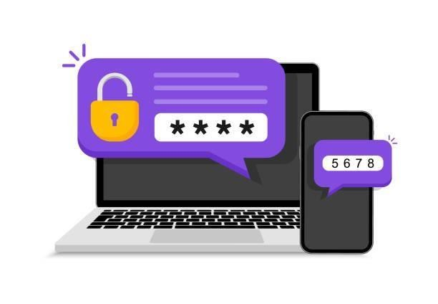Firstly, the Interface of our system will be displayed to the user and the user needs to be authenticated and for that the user needs to fill the user id password given to them. If the user is visiting the interface and the system for the first time then go for the signup button and click it. Then the signup page will open up andenter the user credentials like their basic information and their previous checkups and visits to the hospitals and the treatment taken and then it will redirect the user to the login page and then the user can login as usual and use the system to the fullest.

# Unique Id per User

After the process of login then the users are given their own user unique id for their personal use which differentiates them from the other users. This unique id will be generated 24hrs of the first login done by the user. The unique id is stored in the databases and they are disturbed to the medical society like hospitals, clinics, dorms etc. These unique ids will have the details of the user. These unique user ids are distributed with the databases and the medical information about the user are gathered through the databases to get a visit about

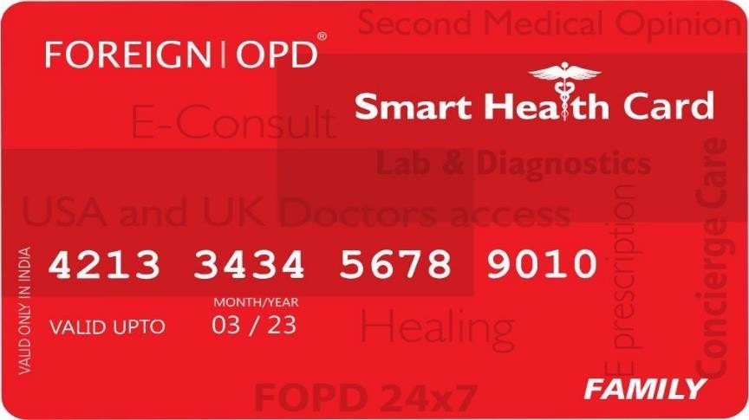the patient’s past and get the necessary references for his speedy recovery.

# Smart Device Tracking

The user interface can be used in several devices and the devices which are used to monitor the body.

The devices like smart watches and smart televisions can be used to view the user’s activities and the information can be directly passed on to the connected devices and those connected devices will display all the credentials and medical values about the user lively. The smart watch can be connected with both Bluetooth and WIFI. These connected devices are given with a default connected range. These connections also include the devices which are embedded in the body and they are also connected to relay the information collected on live. These information about the user include their basic credentials, medical treatments and their hosts and the medication being provided to the patient. All the information is given to the hospitals directly.

# Abnormality Detection

The user is using the system and if the values are not normal then the patient is first alerted to go for a checkup at the nearby hospital and then take treatment for the problem immediately and if the values go beyond abnormal then the system understands that the patient needs immediate medical care due to abnormal medical values, then the software system will make sure it communicates the nearby hospitals and inform the severity and the condition of the patient and ask for assistance immediately. The responded hospitals are filtered out and those hospitals are given priority for the emergency treatment.

